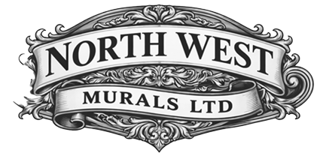

Restoration and Conservation Specialist

CONSERVATION TREATMENT REPORT

Hall of Remembrance, Liverpool Town Hall

Conservation Treatment of Two Marouflage Paintings and Decorative Friezes Following Water Damage
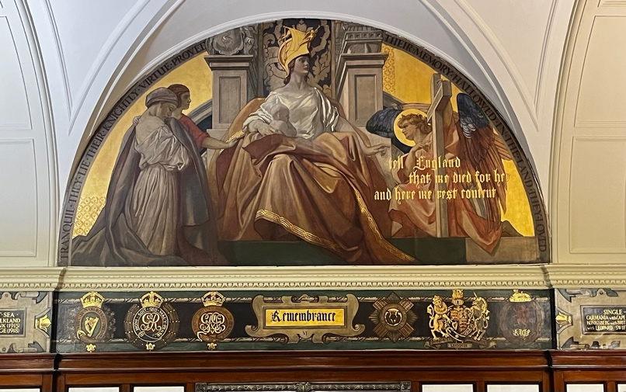
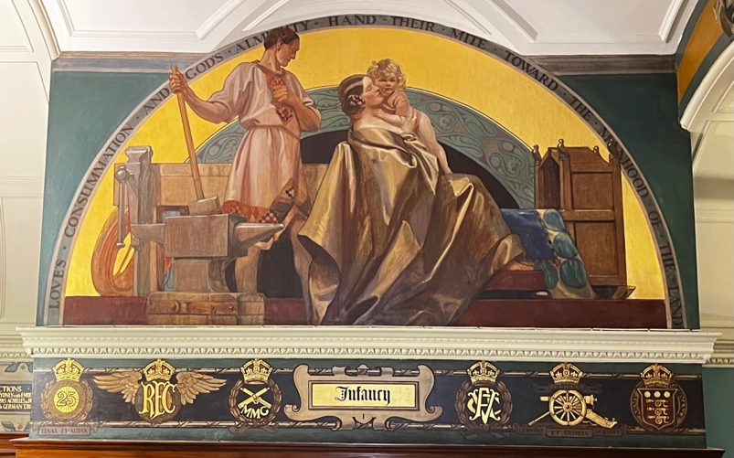

Introduction
This report details the conservation treatment undertaken on two marouflage paintings and associated decorative friezes located within the Hall of Remembrance, Liverpool Town Hall, following water ingress and subsequent deterioration of the painted surfaces.
The objectives of the treatment programme were to assess the condition of the artworks following the water damage incident, remove surface contamination resulting from the event, improve the visual legibility of the painted scheme, and preserve the maximum amount of original material while adhering to accepted conservation principles of minimal intervention and reversibility.

Condition Assessment
A detailed condition assessment was undertaken prior to treatment. The marouflage paintings and decorative friezes exhibited evidence of water-related staining and surface soiling resulting from water ingress into the Hall of Remembrance.
During preliminary cleaning tests, areas of paint abrasion became apparent. Examination indicated that these abrasions were not directly caused by the recent water damage but were the result of excessive cleaning undertaken during a previous conservation campaign. This earlier intervention had reduced the thickness of the original paint layer in certain areas, exposing underlying layers and creating visually disruptive losses.
The water ingress and associated surface contamination had accentuated the visibility of these pre-existing abrasions. Despite the effects of water ingress, the paint layers were found to be stable, with no active flaking, lifting, blistering, or detachment observed. Consequently, no consolidation treatment was required.

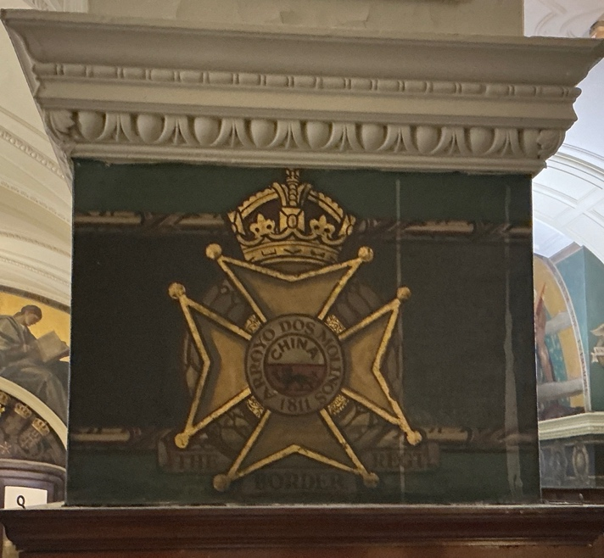
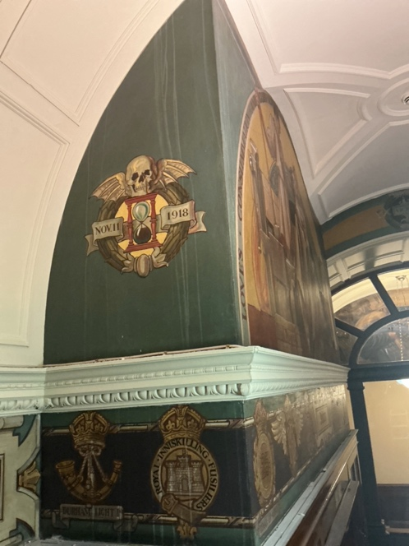
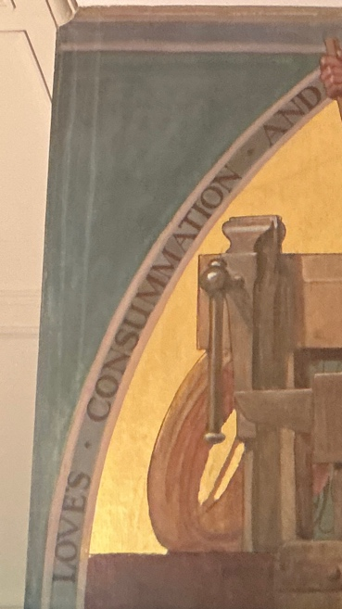
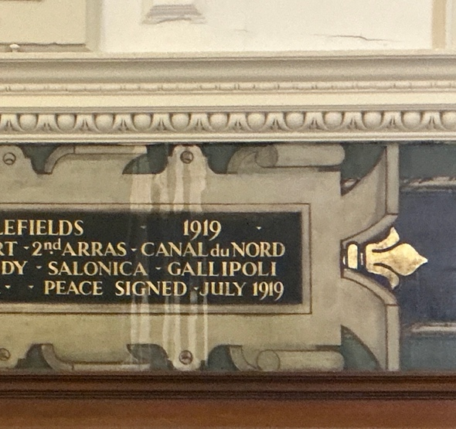
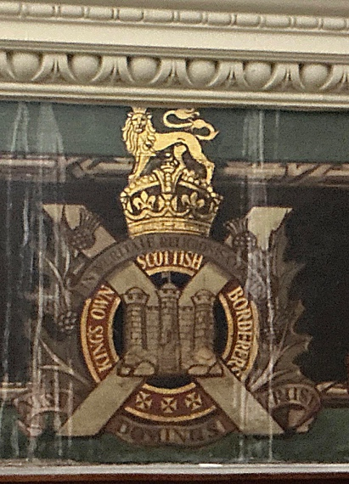
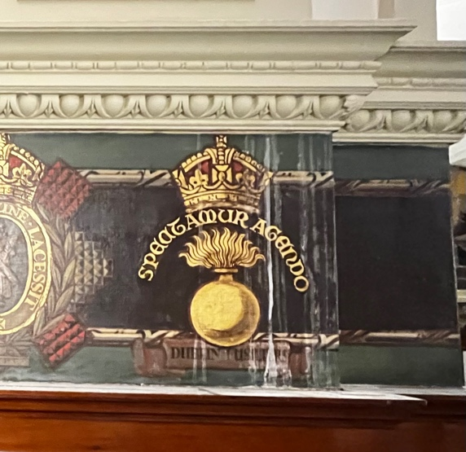

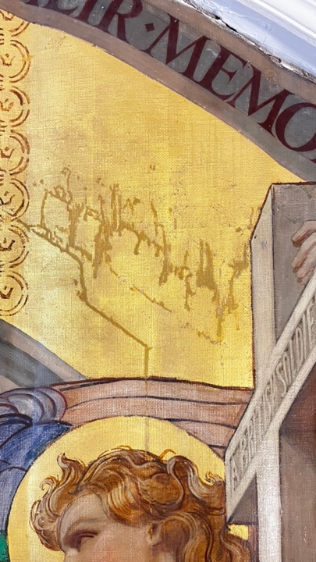
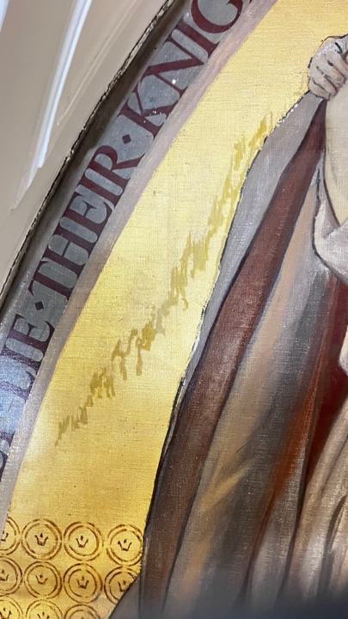
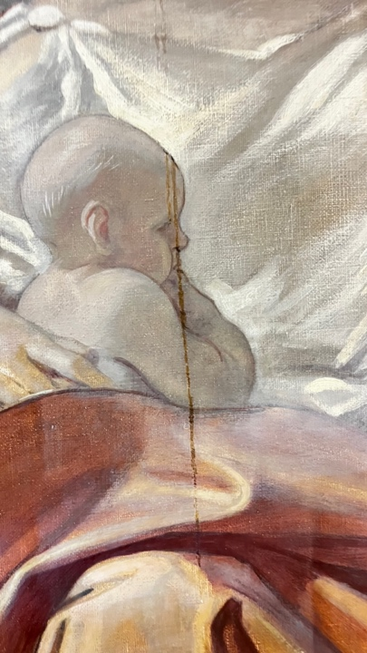

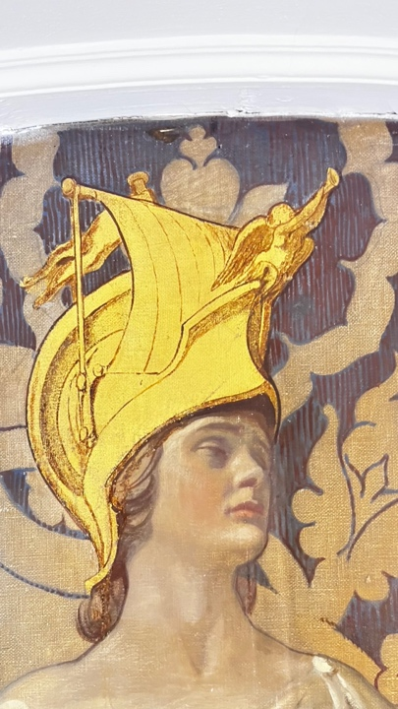
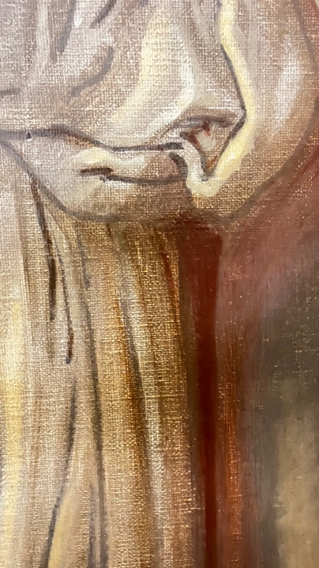
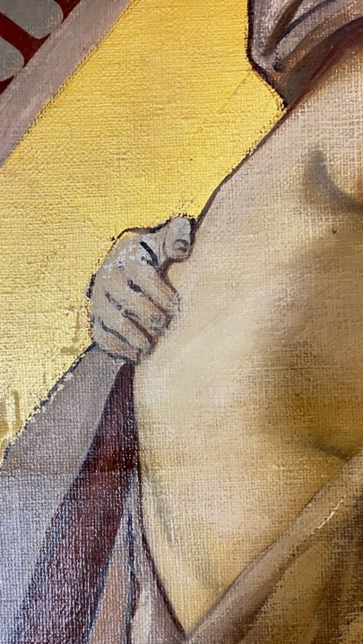

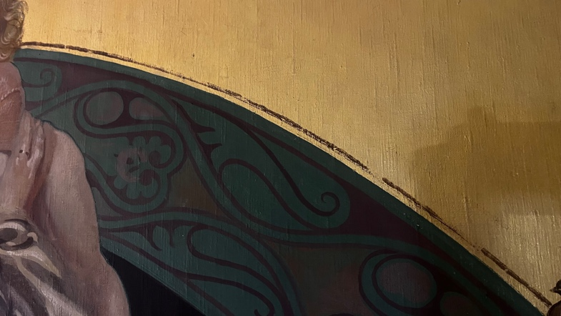
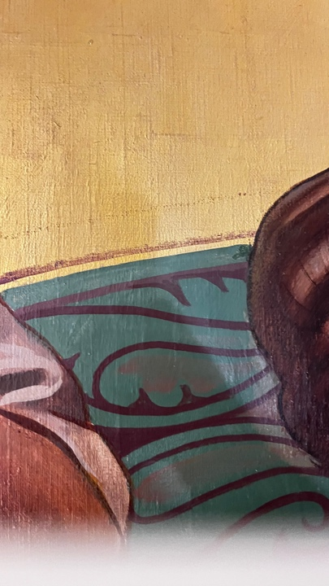
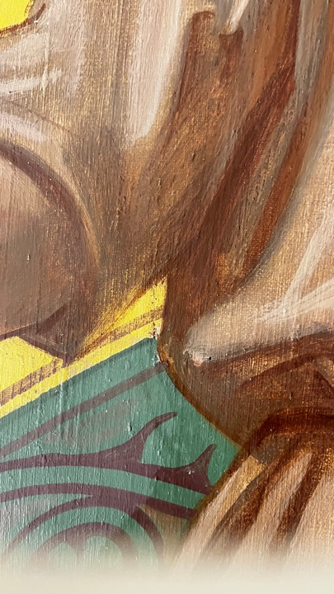

Conservation Treatment
Treatment commenced with full photographic documentation and condition recording of all affected areas.

Surface Cleaning
Surface cleaning was undertaken using a conservation-grade pH-neutral soap formulated for the cleaning of historic decorative painted surfaces. Following testing, the cleaning solution was prepared at a 5% concentration in odourless mineral spirits (OMS) and applied in a controlled manner to remove accumulated surface dirt, grime, and residues associated with the water damage incident.
Particular care was exercised in areas where previous over-cleaning had weakened the original paint surface. Cleaning was carried out incrementally and under close observation to ensure the preservation of all surviving original material.

Inpainting and Visual Reintegration
Following cleaning and assessment, areas of paint abrasion were evaluated for their visual impact and suitability for retouching. It was determined that many of the abrasions had resulted from excessive cleaning undertaken during a previous conservation intervention, which had reduced or removed portions of the original paint layer.
In accordance with recognised conservation ethics, visual reintegration was undertaken selectively and only where losses disrupted the legibility and aesthetic unity of the compositions. Not all abrasions were treated; some were intentionally left visible in order to preserve evidence of the artworks’ conservation history and to avoid unnecessary reconstruction of lost original material.
Inpainting was undertaken using Paraloid B-72 prepared as a 20% (w/v) solution in a 1:1 mixture of acetone and industrial methylated spirits (IMS) combained with Conservation-grade pigments. Retouching was carried out using a combination of glazing, tratteggio, and punteggio techniques. Transparent glazes were employed to reduce the visual prominence of abraded areas while allowing surviving original material to remain discernible. Where appropriate, tratteggio and punteggio techniques were used to integrate losses in a manner that achieved visual coherence from a normal viewing distance while remaining distinguishable upon close examination.
All inpainting and retouching materials employed during treatment were conservation-grade, stable, and fully reversible archival materials. These materials were selected to ensure compatibility with the original paint layers and to allow for future examination, retreatment, or removal without causing damage to the original artwork.

Materials Used

Cleaning Materials
- Conservation-grade pH-neutral cleaning soap.
- Odourless Mineral Spirits (OMS).

Inpainting Materials
- Paraloid B-72 acrylic resin.
- Acetone.
- Industrial Methylated Spirits (IMS).
- Conservation-grade pigments for colour matching and visual reintegration.

Results
The conservation treatment successfully removed surface contamination associated with the water damage incident and improved the overall legibility of the marouflage paintings and decorative friezes.
The treatment also revealed and documented evidence of historic over-cleaning, which had caused abrasion and thinning of the original paint layers in several locations. Through careful cleaning and selective visual reintegration, the visual impact of these abrasions was significantly reduced without compromising the authenticity of the original painted surfaces.
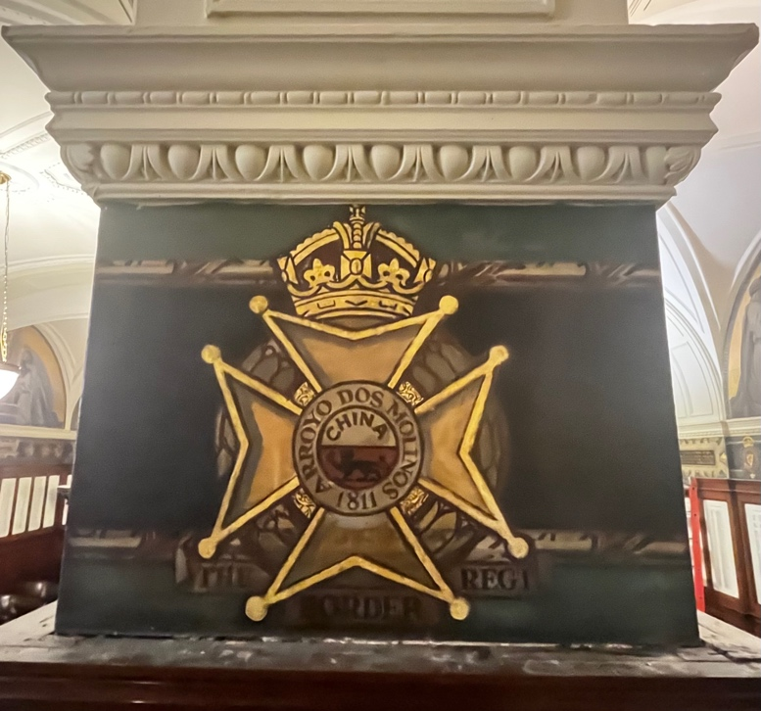
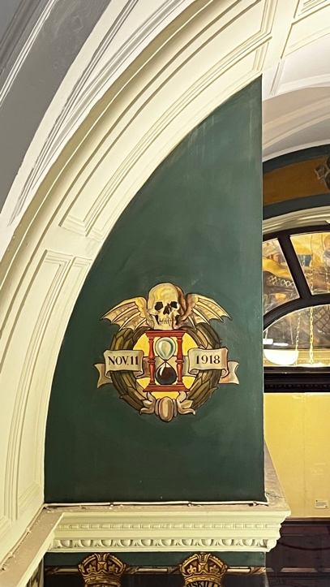
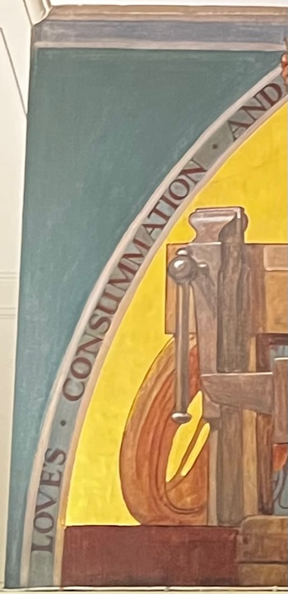
The combined use of glazing, tratteggio, and punteggio techniques enabled the successful integration of selected losses while maintaining a clear distinction between original material and conservation intervention. Areas of historic abrasion that did not adversely affect the overall reading of the compositions were intentionally left untreated as part of the objects’ conservation history.

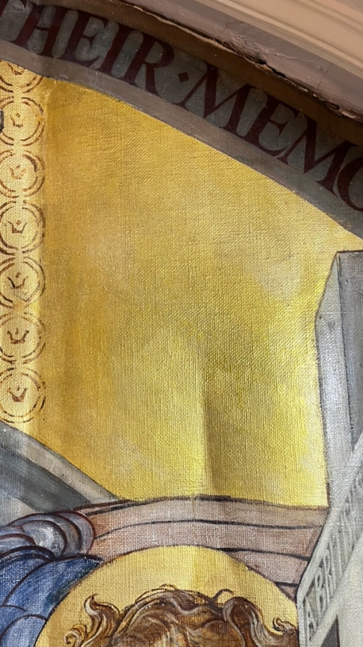
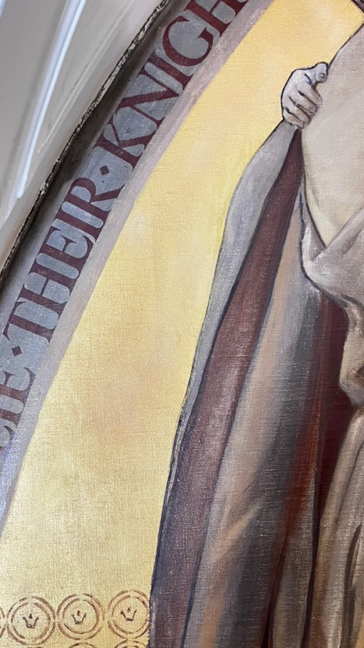
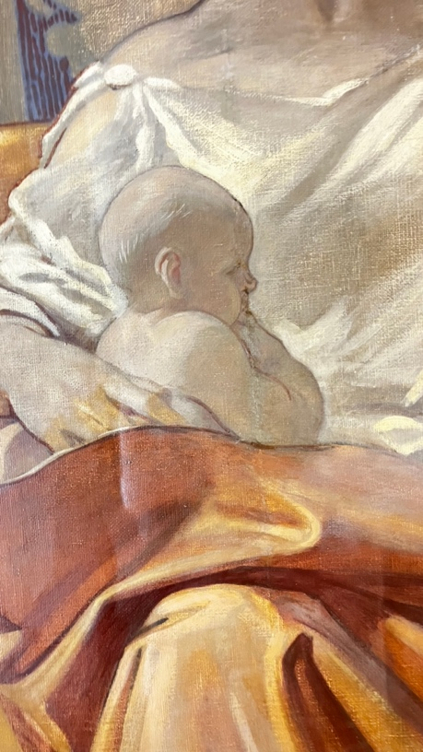
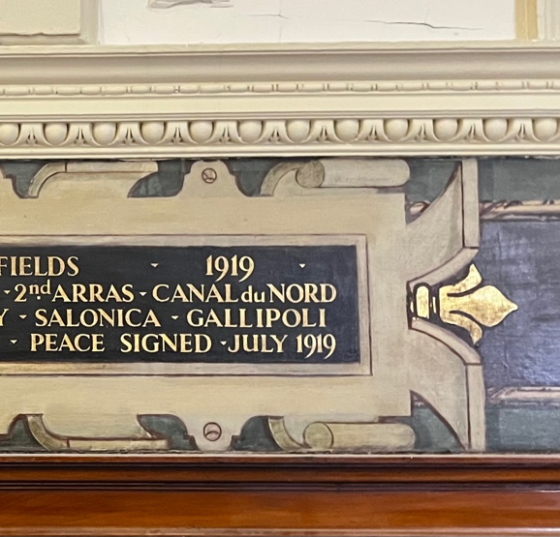
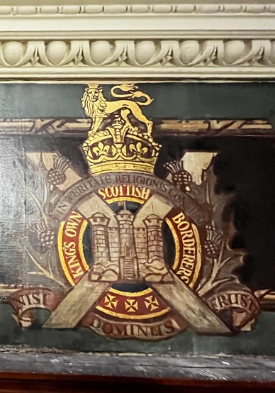
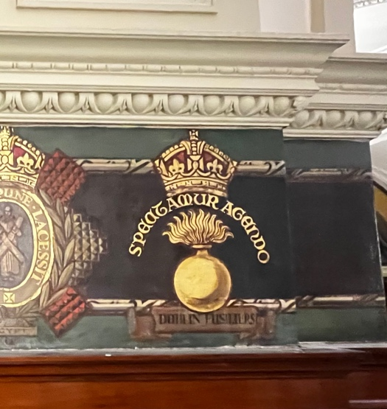

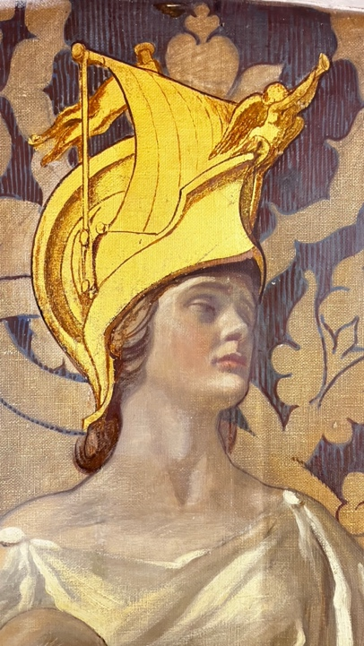
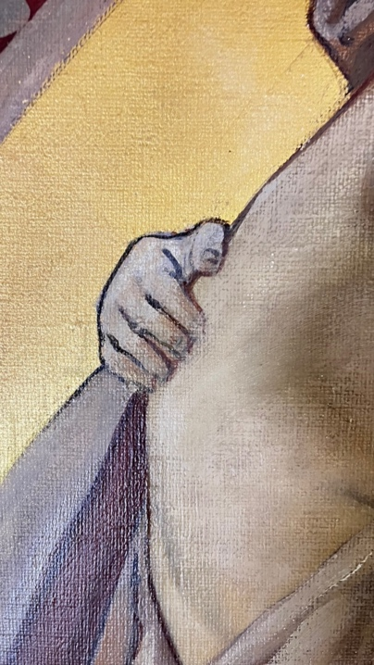

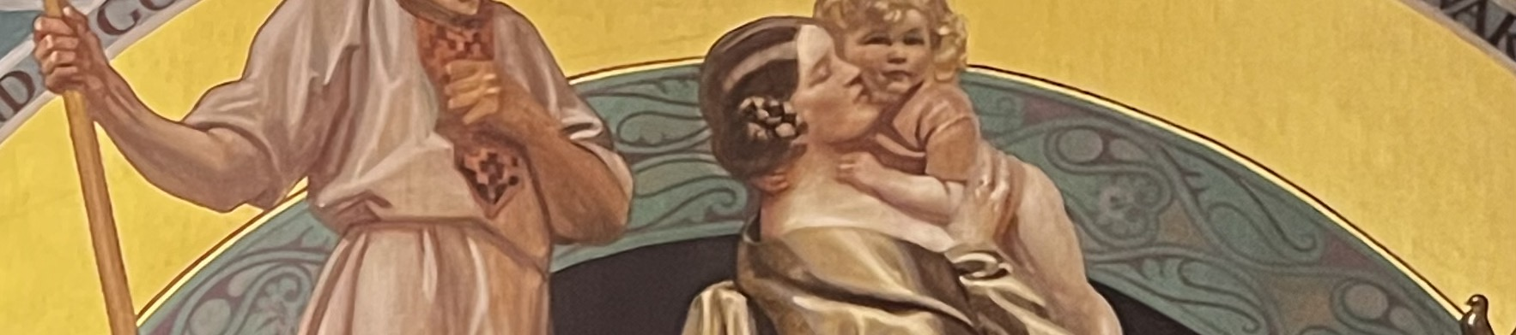

Recommendations
- Continue regular environmental monitoring within the Hall of Remembrance, with particular attention to potential sources of water ingress and fluctuations in relative humidity.
- Undertake periodic condition inspections of the marouflage paintings and decorative friezes to monitor any future changes.
- Avoid aggressive cleaning methods during routine maintenance.
- Ensure that any future conservation interventions are preceded by appropriate testing and undertaken by qualified conservators.
- Maintain photographic and written records to support future conservation management and condition monitoring.

Conclusion
The conservation treatment programme successfully addressed the effects of water ingress affecting the two marouflage paintings and decorative friezes within the Hall of Remembrance, Liverpool Town Hall.
Cleaning removed surface contamination and improved the legibility of the decorative scheme, while careful examination revealed evidence of abrasion resulting from a previous over-cleaning campaign. Selective visual reintegration using glazing, tratteggio, and punteggio techniques reduced the visual impact of these abrasions while preserving the integrity and authenticity of the original painted surfaces.
All inpainting and retouching interventions were undertaken using reversible archival materials in accordance with current professional conservation standards, ensuring that future treatment remains possible without compromising the original fabric of the artworks.
The treatment has stabilised the presentation of these important historic decorative elements and contributes to their continued preservation and appreciation within the Hall of Remembrance at Liverpool Town Hall.
Report Prepared By
Silvano Cioci Faux
Conservator at North West Murals Ltd
Signature:
Date: 15\06\2026

